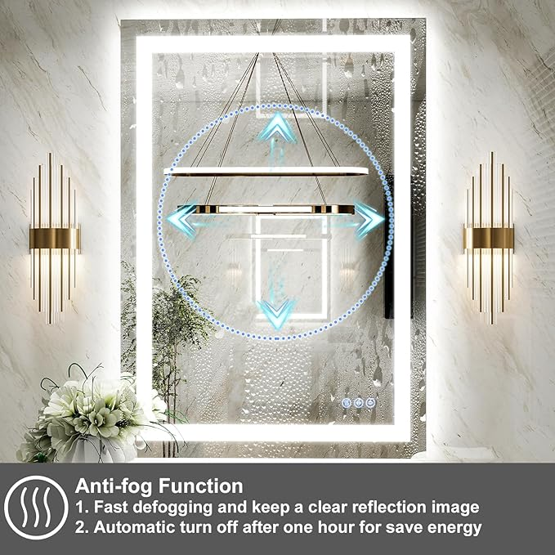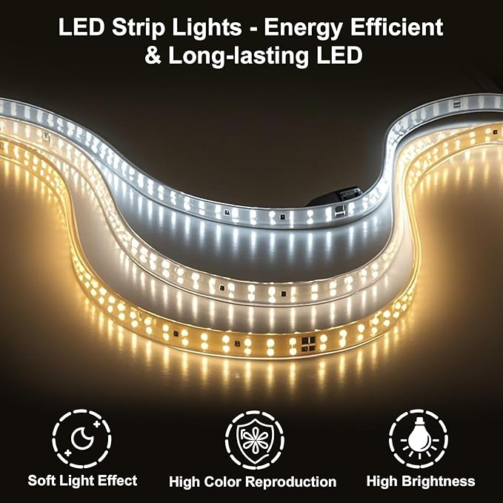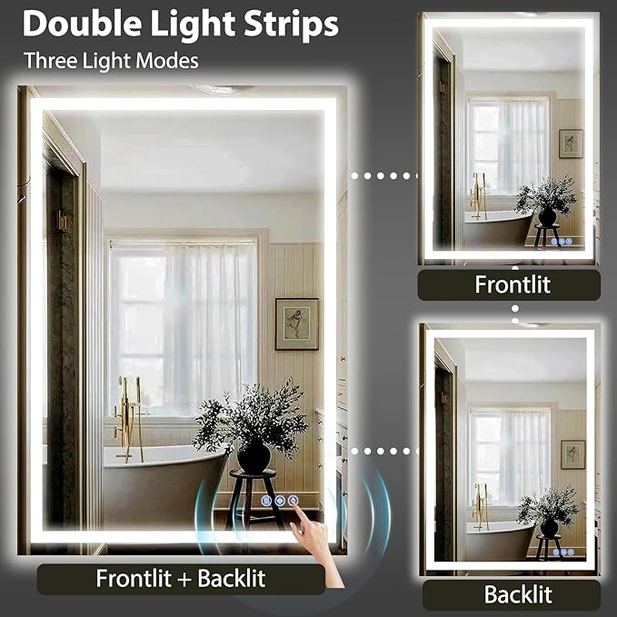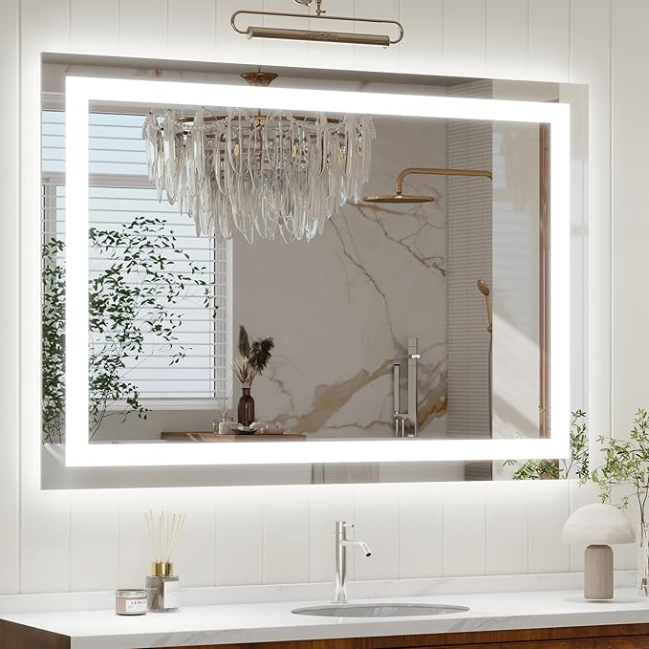

GLSLAND 24"x36" LED Bathroom Mirror with Lights, Dimmable Front and Backlit Vanity Mirrors, Wall Mounted Anti-Fog Lighted Mirror, Horizontal/Vertical Hanging

**PRODUCT DESCRIPTION:**

|  |  |
| --- | --- |
| Brand | GLSLAND |
| Room Type | Cloakroom, Bathroom, Bedroom, Living Room |
| Shape | Rectangular |
| Product Dimensions | 36"L x 24"W |
| Frame Material | Glass |

**About this item**

* Dimmable LED Bathroom Mirror - This LED vanity mirror gives you 3 different lighting options: white, natural and warm .You can choose the light color suitable for different occasions and environments according to your needs to get more comfortable and meet the requirements of the lighting effect
* Front Light & Back Light - This LED mirror is equipped with double quality energy-saving LED light strips, providing light from the back and front with double lights.The combination of frontlit and backlit creates a more comprehensive and uniform lighting effect, enhancing the user's visual experience when using bathroom mirrors
* Anti-Fog - This smart bathroom led mirror features an anti-fog function. It helps resist the troubling fog and keep a clear reflection image. To save energy, the bathroom vanity mirror with lights will automatically turn off after one hour
* Explosion-Proof Glass - Elevate your bathroom with our dimmable led bathroom vanity mirror, featuring explosion-proof glass.This advanced glass technology ensures safety and durability, providing you with peace of mind
* Versatile Hanging Options - Our bathroom mirror with light can be hung horizontally or vertically, providing you with flexibility in installation